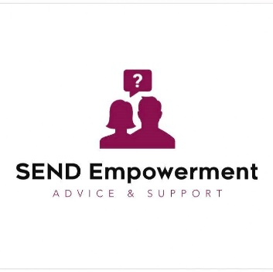
Preparing for a Meeting with School About Your Child with SEND

For parents and carers in England

Purpose of This Guide
This guide will help you prepare confidently for a school meeting about your child’s Special Educational Needs and/or Disabilities (SEND). Whether it’s a regular review, a planning meeting, or a concern you’ve raised, being prepared can make a big difference in getting the right support in place.

Types of Meetings You Might Attend
- SEND review meeting (linked to a SEN Support plan)
- Annual Review of an Education, Health and Care Plan (EHCP)
- Early discussion to identify needs
- Transition planning (e.g. starting a new school)
- Emergency meetings following incidents or significant changes
- Multi-agency meetings with external professionals (SALT, OT, EP, etc.)

Step-by-Step Guide to Preparing

1. Know What the Meeting Is For
Ask the school:
- What is the purpose of the meeting?
- Who will be attending?
- Will any reports or updates be shared beforehand?
- Will the SENCo be present?
➡️ Tip: Ask for an agenda if possible, or suggest one.

2. Gather & Organise Key Information
Create a folder or file (digital or printed) with:
- School reports and previous meeting notes
- Your child’s SEND plan / provision map / EHCP (if applicable)
- Letters or emails between you and the school
- Professional reports: Educational Psychologist, Speech & Language, CAMHS, etc.
- Your own notes about concerns, strengths, behaviours, or progress
➡️ Tip: Highlight anything that’s changed, improved, or worsened recently.

3. Make a List of Questions & Concerns
This keeps the meeting focused and ensures your voice is heard. Consider:
- What progress is my child making?
- What support is currently in place?
- Is it being delivered as planned?
- How is the school monitoring outcomes?
- Do teachers understand my child’s needs?
- Is more help or specialist input needed?
- Are we ready to consider an EHCP?
Tip: Write questions down and take them with you — it’s easy to forget in the moment.

4. Know Your Rights
Under the SEND Code of Practice, you have the right to:
- Be involved in decisions about your child’s support
- Receive clear information
- Be part of reviews
- Request an EHC needs assessment if SEN Support isn’t enough
Reminder: You are the expert on your child.

5. Take Someone With You
- A trusted friend, family member, or independent advocate can:
  - Take notes
  - Help you feel confident
  - Support you emotionally
- Let the school know in advance if someone is coming with you
Tip: You can ask to record the meeting (with permission), or take written notes for reference later.

6. During the Meeting
- Stay calm, clear, and focused
- Stick to facts and lived experiences
- Use your notes and ask your questions
- Ask for explanations if you're unsure (e.g. acronyms or terms)
- Challenge gently if something doesn't seem right
Phrase to use:
"Can you help me understand how this support is being delivered?"
"What evidence do we have that it’s working or not working?"

7. After the Meeting
- Ask for written minutes or a follow-up email summarising what was agreed
- Write your own brief summary if nothing is sent
- Clarify any next steps, timelines, or follow-up meetings
- Save everything in your SEND folder
Tip: If nothing changes or you disagree with the outcome, you can raise concerns in writing or seek independent advice.

Common Concerns to Bring Up (If Relevant)
- “My child is struggling despite support — what can we do differently?”
- “Support isn’t being provided as agreed — how can this be addressed?”
- “We need advice from external professionals — how can we access it?”
- “I think we may need to request an EHC Needs Assessment.”

Final Tips for a Positive Meeting
- You are not being difficult — you are advocating for your child
- Stay polite but assertive
- Keep the focus on outcomes – how can your child make progress and feel supported?
- Make it a partnership: “How can we work together on this?”

Need Support?
As independent SEND advocates, we can:
- Help you prepare your notes or questions
- Join you in meetings (virtually or in-person, where possible)
- Explain your rights and options in plain English
📧 info@send-empowerment.co.uk
📞 07354 731467

